Press Release Naomi W. Knight
FOR IMMEDIATE RELEASE Maryland FFA Program Coordinator
April 8, 2025 nknight@maefonline.com

MARYLAND FFA FOUNDATION ANNOUNCES RECIPIENTS OF THE GIFT OF BLUE
(HAVRE DE GRACE, MARYLAND) – April 5, 2025- The Maryland FFA Foundation is pleased to announce their annual recipients of the Gift of Blue Program. This program benefits those deserving and active FFA members in grades 9-11. Each chapter is eligible to request up to three FFA jackets at a cost of $20/jacket.
This year, 90 students representing 31 chapters received their own FFA jacket and matching tie/scarf in a presentation during a ceremony at the State Spring Judging Event on April 5, 2025 at Carroll County Career and Technology Center in Westminster, MD. The event hosted over 500 members, advisors, parents and volunteers. The Maryland FFA Foundation has sponsored this generous event for the past ten years awarding 933 jackets to deserving members totaling over $46,750 through their foundation.
Region 1
Boonsboro: Sarah Cook, Samantha DeLeo, Aubrey Sigler
Boonsboro Middle: Jaycen Jenkins, Mallory Johnikin, Ashlynn Snodderly
Boyd J. Michael III Tech: Josie Dominick, Bryanna Gay, Kayte Trice
Clear Spring: Sydney Arena, Arianna Cantner, Addison Fitz
Smithsburg: Haley Doyle, Brynn Hurd, Skylar Shaffer
Region 2
Brunswick: Katelyn Hargett, Sophia Hargett, Catherine Orndorff
Catoctin: Grady Abruzzese, Jonathan Guldan, Jackson Savage
Frederick: Natalia Gehm, Brayden Manahan, Samantha Thomas
Frederick CTC: Emerson Maland
Linganore: Jesse Garver, Kat Medellin, Liz Van Meter
Middletown: Kerrigan Glotfelty, Joellen Honeycutt, Breanna White
Oakdale: Carys Decker, Emerson Kraft, Ariana Tarlan
Tuscarora: Klayre Richardson, Jacob Wainberg, Jacob Wilcox
Urbana: Pari Desai, Sophia Houston, Meredith Walker
Walkersville: Lena Meletic, Emylee Sheets, Hayden Tennant

Region 3
Calvert: Eljah Mason, Lilly Payne, Penelope Pugner
CAT-North: Delyla Dodd, Julz Lechuk, Denise Walker
Damascus: Ashtyn Manoogian, Jenna Sherman, Rachel Sherman
Gwynn Park:, Evelyn Brown, Daniela Umanzor, Kevin Bonilla
Howard County: Brooke LaFountain, Maia Shoots, Summer Yowell
Southern: Clint Dorval, Rylee Hardesty, Claire Ogilvie
Region 4
Century: Taylor Flanagan, David Snorgrass-Wells, Claire Superczynski
Francis Scott Key: Ella Fritz, Rowan Kiser, Hailey Putman
Harford Tech: Abbie Brodeur, Rebekah Layton, Olivia Melvern
Manchester Valley: Jadyn Greenwell, Nicholas Kilgore, Steven Long
North Harford: Lucy Heisey, Blakely Jackanicz, Jack Miklos
South Carroll: Maddie Gordon, Austin Hatfield, Brooklyn Valenzia
Westminster: Rysen Doucette, Laura Scott, Jaan Vazquez-Fedele
Winters Mill: Arlin Price, Emily Repp, Anjali Ugalde
Region 5
Queen Anne’s County: Joel Escalante, Caroline Gunter, Charles Nickerson
Worcester Tech: Remington Betts, Madison Mitchell

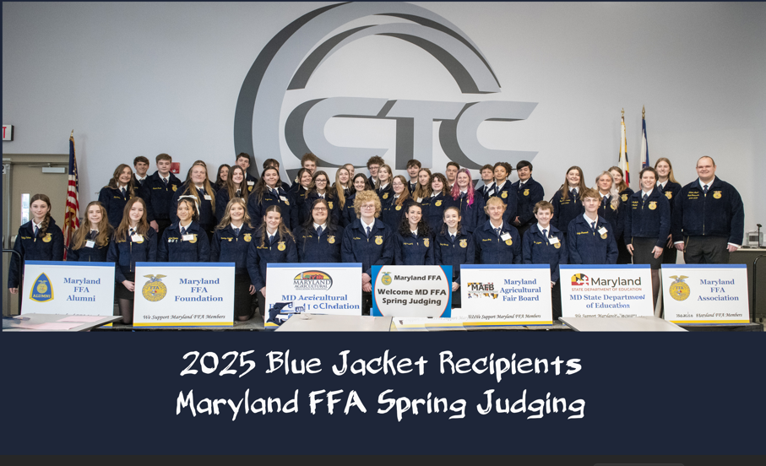

The Maryland Agricultural Education Foundation is a 501c3 non-governmental nonprofit established in 1989. Through the Maryland FFA, teacher workshops, scholarships, grants, Mobile Labs and Showcases, and revenues from the Ag Tag license plate sales, the Foundation pursues its mission to promote the understanding and appreciation of the importance of agriculture in everyone’s daily lives. The Maryland FFA Association’s staff team is partially funded through a $60,000 federal Perkins Grant facilitated by the Maryland State Department of Education. The Maryland FFA Association has 2,421 active members in 47 Chapters throughout the State.
For more information, visit www.mdffa.org or contact Naomi Knight at nknight@maefonline.com

